SOLUBILITY

BEHAVIOUR OBJECTIVES
At the end of this lesson, students should be able to:
- explain the terms; solute, solvent, solution, saturated, un-saturated and super saturated solution, solubility.
- differentiate unsaturated, saturated and super saturated solutions.
- list at least 3 factors affecting solubility.
- calculate solubility of solutes in solvents.
- list and discuss at least 3 applications of solubility and solubility curve in daily life and industries.

Solubility is from the word ‘SOUBLE’ which means TO DISSOLVE.
SOLUTE: it is a substance that dissolves in a solvent to form a solution. It is the smaller proportion of the solution. It can be solid, liquid or gas.
SOLVENT: A substance that dissolves a solute to form a solution. It is the larger proportion of the solution. It can be liquid, solid or gas.
SOLUTION: a homogenous mixture of two or more substances. It is the mixture of solute and solvent.
Solute + solvent = Solution

TYPES OF SOLUTION
Un-Saturated Solution: a solution which contains less than the solute than it can dissolve at a particular temperature.
Saturated Solution: a which contains as much solute as it can dissolve at a temperature in the presence of undissolved particles. In a saturated solution, the dissolved solutes and undissolved solutes are in equilibrium at that given temperature. e.g. brine.
Super-Saturated Solution: a solution that contains more solute than it can dissolve at a particular temperature.

SOLUBILITY
The solubility of a solute in a solvent at a particular temperature is the maximum amount of solute in moles or grams that will dissolve in 1dm³ of the solvent at that temperature. solubility can be measured in moldm⁻³ or gdm⁻³.
Solubility in moldm⁻³ = $\frac{\text{ mass }}{\text{ Molar mass }}\text{ × }\frac{\text{ 1000 }}{\text{ volume }}$
Solubility in gdm⁻³ = $\frac{\text{ mass of solute }}{\text{ volume of solvent }}\text{ × }\frac{\text{ 1000 }}{\text{ 1 }}$

FACTORS AFFECTING SOLUBILITY
- Nature of solvent and solute: Generally, polar solute dissolves in polar solvent while non-polar solute dissolves in non-polar solvent.

- Temperature: The solubility of salt increases with a rise in temperature till a point of saturation is reached while solubility of gases decreases with rising temperature.(except hydrogen sulphide).

- Pressure: As the pressure of a gas is increased, the collision frequency increases and thus the solubility goes up, as the pressure is decreased, the solubility goes down.

SOLUBILITY CURVE
The solubilities of a solute in a particular solvent at different temperature can be represented graphically by plotting solubility as a function of temperature. This is called solubility curve. A plot of solubility against temperature.

SOLUBILITY CURVE OF SALT
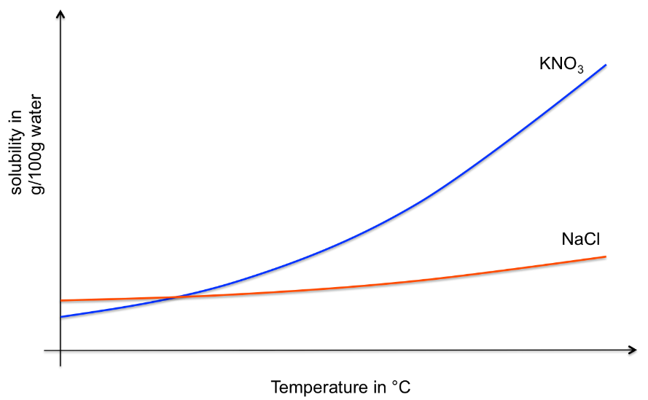

APPLICATION OF SOLUBILITY AND SOLUBILITY CURVE
- To determine the amounts of drugs that must be dissolved in a particular quantity of solvent to give a prescribed drug mixture.
- To identify the most suitable solvents for the extraction of solutes from natural sources.
- To separate and purify mixture of solids.
- It is applied in fractional crystallization.

CALCULATIONS ON SOLUBILITY
- On heating 25g of a saturated solution to dryness at 60ºC, 4g anhydrous salt was recovered. Calculate its solubility in grams per 100 of solvent.
Mass of solute = 4g mass of solution = 25g
Mass of solvent= mass of solution – mass of solute = 25 – 4 = 21g
But since the question asked for the solubility in gram per 100g of the solvent, therefore the volume of the solvent would be divided by 100 not 1000
Solubility in gdm⁻³ = $\frac{\text{ mass of solute }}{\text{ volume of solvent }}\text{ × }\frac{\text{ 1000 }}{\text{ 1 }}$
Since, 1g =1 cm³
$= \frac{\text{4}}{\text{21}}\text{ ×} \text{100}=$ 19.05$\frac{\text{g}}{\text{100}}$
- What is the solubility in moledm⁻³ of 20.0g of KNO₃ dissolved in 100g of water at room temperature? [K=39, O=16, N=14]
Since 1g of water = 1 cm³ of water, 100g = 100cm³
Mass of KNO₃ = 20g molar mass of KNO₃ = 39 + 14 +3(16) = 101
Mole = $\frac{\text{mass}}{\text{molar mass}}\text{= }\frac{\text{20}}{\text{101}}\text{=0.198moles}$
Solubility in moledm⁻³ = $\frac{\text{ mole of solute }}{\text{ volume of solvent }}\text{ × }\frac{\text{ 1000 }}{\text{ 1 }}$
$\text{=}\frac{\text{0.198}}{\text{100}}\text{ × }\frac{\text{1000}}{\text{1}}\text{= 1.98moles}$

- 1.33dm³ of water at 70ºC are saturated by 2.25 moles of lead(II)trioxonitrate(V), Pb(NO₃)₂, and 1.33dm³ of water at 18^{O}C are saturated by 0.53 mole of the same salt. If 4.50dm³ of the saturated solution are cooled from 70ºC to 18ºC. Calculate the amount of the solute that will be deposited in; a. moles b. grams
volume of water at 70 °C = 1.33 dm³
moles of Pb(NO₃)₂ at 70 °C = 2.25 moles
moles of Pb(NO₃)₂ at 18 °C = 0.53 moles
Solubility of Pb(NO₃)₂ at 18 °C in moldm⁻³ = $\frac{\text{ mole of solute}}{\text{ volume of solvent} }$
$\text{= }\frac{\text{0.53}}{\text{1.33}}\text{=0.398}$ moldm⁻³
Solubility of Pb(NO₃)₂ at 70°C in moldm⁻³ = $\frac{\text{mole of solute}}{\text{ volume of solvent} }$
$\text{= }\frac{\text{2.25}}{\text{1.33}}\text{= }$1.692 moldm⁻³

moles of Pb(NO₃)₂ in 4.50 dm³ at 70 °C = solubility $×$ volume of solvent
= 1.692 $×$ 4.5 = 7.614 moles
moles of Pb(NO₃)₂ in 4.50 dm³ at 18 °C = solubility $×$ volume of solvent
= 0.398 $×$ 4.5 = 1.791 moles

Number of moles that precipitate out = The amount of solute deposited
- Amount of solute deposited = 7.613 moles - 1.79 moles = 5.823 moles

- Molar mass of Pb(NO₃)₂ = 207 g + 2 × (14 g + 3 × 16 g) = 331 g
The amount of solute deposited = Number of moles × Molar mass
= 5.823 moles × 331 g/mol = 1927.413 g

DRILL QUESTIONS

- What is the solubility of a salt X if 50cm³ of a saturated solution contain 8.0g of X? [X=60gmol⁻¹]
- 3.67moldm⁻³
- 2.67moldm⁻³
- 1.67moldm⁻³
- 0.67moldm⁻³

- When crystal was added to the solution of its salt, the crystal did not dissolve and the solution remained unchanged. This showed that the solution was ………….?
- Supersaturated
- Unsaturated
- Saturated
- Concentrated

- A change in temperature of a solution of saturated solution disturbed the equilibrium between the …………….?
- dissolve solute and the solution
- dissolve solute and the undissolved solute
- dissolve solute and the solvent
- solvent and undissolved solute

- The solubility curve shows the variation of solute concentration with ………….?
- Volumes
- vapour density
- pressure
- temperature

- The solubility of a salt of molar mass 101g/mol at 20⁰C is 0.34moldm-3. If 3.40g of the salt is dissolved completely in 250cm3 of water in a beaker, the resulting solution?
- unsaturated
- suspension
- saturated
- super saturated

ANSWER
- B
- C
- B
- D
- A

